 CHEMICAL ENGINEERING TRANSACTIONS  VOL. xxx, 2025 | A publication of  
The Italian Association
of Chemical Engineering
Online at www.cetjournal.it

Guest Editors: Fabrizio Bezzo, Flavio Manenti, Gabriele Pannocchia, Almerinda di Benedetto
Copyright © 2025, AIDIC Servizi S.r.l.
ISBN 979-12-81206-17-5; ISSN 2283-9216

Innovative Powder Reuse Strategy in the Selective Laser Sintering Process Using a Fluidized Bed System
Daniele Sofia¹*, Rossella Girimonte¹

ª Department of Computer Engineering, Modeling, Electronics and Systems, University of Calabria, Via P. Bucci cubo 44/a Rende (CS), 87036, ITALY
*daniele.sofia@unical.it
This study introduces an innovative method for the recovery and reuse of unsintered powder in the Selective Laser Sintering (SLS) process, widely used in additive manufacturing for creating complex components with a broad range of powder materials. The main challenge in this process is the effective management of unsintered powder, particularly the separation of aggregates formed during the sintering phase, to avoid compromising the properties of the reused material. The proposed fluidized bed system employs a gas flow to fluidize the powder, effectively separating the aggregates and restoring the powder's granularity to a quality similar to its original state. This process not only improves material efficiency by reducing waste but also maintains the desired properties of the powder for continuous reuse in the SLS process.
Experimental results demonstrate that the powder recovered through this method retains its essential characteristics, such as particle size distribution and flow properties, enabling its direct reuse in the SLS process work chamber. This approach represents a significant step toward sustainability and economic efficiency in additive manufacturing, providing a viable solution for powder reuse and reducing the environmental impact associated with the production of new powder.
  - Introduction

Selective Laser Sintering (SLS) stands as one of the forefront technologies in the field of additive manufacturing, offering the capability to create complex components with a wide array of materials. Despite its undeniable advantages, the SLS process is accompanied by specific technical challenges, including the management of unsintered powder (Luo X. et al, 2014). Effective separation of powder in the SLS process is crucial for maintaining the high quality of finished parts and the efficiency of the production process. Aggregates formed during sintering, if not removed, can compromise the quality of the produced components, causing surface defects, undesired porosity, and, in extreme cases, structural failure of the piece.
Traditionally employed techniques for powder separation in the SLS process include mechanical methods such as sieving and filtration. While these techniques can be effective to a certain extent, they have limitations in terms of efficiency, especially when it comes to separating particles of very similar sizes or removing finely dispersed aggregates (Liu C. et al, 2007). These methods may also require significant manual interventions, increasing downtime in the process and impacting overall productivity.
Fluidized bed separation emerges as a promising technique to address these challenges. This method leverages a gas flow to fluidize the powder, allowing for an effective and automatic separation of aggregates from fine powders (Ojala L.S. et al, 2016). The ability to operate continuously and automatically makes fluidized bed separation an ideal solution to minimize downtime in the SLS process, significantly enhancing production efficiency. Moreover, its effectiveness in recovering powder of a quality similar to the original supports material reuse, helping to reduce costs associated with producing new powder and the environmental impact of the process.
Adopting a fluidized bed system for powder separation in the SLS process represents a significant advancement towards more sustainable and economically efficient additive manufacturing processes (Gu D.D. et al, 2012). The capability of this method to ensure a quick and automated recovery of powder not only optimizes resource use but also paves the way for broader adoption of SLS technology in production areas where powder management is a critical bottleneck.
Thus, the aim of this study is to develop and validate a fluidized bed system capable of efficiently recovering and reusing unsintered powder in the SLS process. The proposed approach ensures consistent material quality while minimizing waste and environmental impact. This research addresses the problem of ineffective powder reuse in additive manufacturing, optimizing resource utilization and promoting a more sustainable production model.

  - Materials and Methods

In this study, we adopted an innovative approach for the recovery and reuse of unsintered powder in the Selective Laser Sintering (SLS) process, leveraging the unique capabilities of the Sintratec Kit SLS apparatus and Sintratec PA12 Powder polymer, combined with the use of a fluidized bed column for effective separation of aggregates from the powder. Below, we provide a detailed description of the materials and methods used.

    - Materials
Sintering (SLS) 3D printing, widely used in industrial additive manufacturing. Known for its exceptional mechanical strength, durability, and precision, it is ideal for creating both functional prototypes and end-use parts (Bertrand P. et al, 2007).
PA12 Powder’s key advantages include its ability to withstand significant mechanical stress, impact, and fatigue, making it suitable for demanding environments. It also maintains integrity under high temperatures and resists a variety of chemicals, ensuring longevity and reliability. The powder offers excellent dimensional stability and precision, producing parts with tight tolerances.
While SLS parts typically have a rough surface texture, PA12 parts can be post-processed for a smoother finish if needed (Kahrizsangi S. et al, 2015). The material’s versatility makes it suitable for various industries such as automotive, aerospace, consumer goods, and medical devices. It enables the creation of complex designs without support structures, reducing waste and increasing efficiency.
PA12 is used extensively for durable components like hinges and gears in the automotive and aerospace sectors, custom prosthetics and surgical instruments in medical fields, and consumer products like protective cases and sports equipment. Its robustness and versatility make it a valuable material for innovative and reliable 3D printing solutions (Lupo M. et al, 2023).
Table 1: Characteristics of PA12 Powder.
Materials | T_{m} (◦C) | ρ_{B} (kg/m3) | ρ_{P} (kg/m3) | d₁₀ (μm) | d₅₀ (μm) | d₉₀ (μm) | d_{3,2} (μm) | d_{4,3} (μm)
PA12 | 210 | 525 | 1130 | 15 | 46 | 91 | 20 | 50

Sintratec PA12 Powder is a cornerstone material in SLS 3D printing, offering a harmonious balance of performance, durability, and versatility. Its widespread adoption not only drives innovation in design and product development but also promotes sustainable manufacturing practices by optimizing material use and minimizing waste (Lupo M. et al, 2019). This material is truly at the forefront of advancing the capabilities and applications of additive manufacturing.
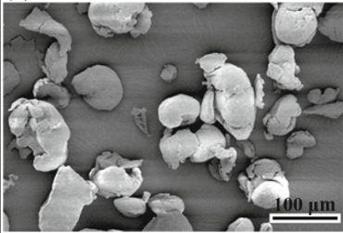
Figure 1. Electron microscopy of PA12 powder.
    - SLS apparatus

For this study, we used the Sintratec Kit SLS apparatus, chosen for its innovative design and research-friendly features. This system is particularly advantageous because of its open parameter settings, which allow precise adjustments to key printing parameters such as laser speed and temperature. These adjustments are crucial for tailoring the SLS process to various materials and experimental needs.
The Sintratec Kit offers a maximum print volume of 110 x 110 x 110 mm, providing ample space for diverse experimental designs. However, for optimal results, we recommend a print volume of 90 x 90 x 90 mm. The laser speed is highly adjustable, ranging from 5 to 600 mm/s, enabling fine-tuning to suit different materials and desired print qualities.
Layer height can be set between 100 and 150 µm, which facilitates the creation of detailed and precise layers. The overall dimensions of the apparatus are 520 x 520 x 360 mm, making it compact yet powerful. Weighing 36 kg, the unit is stable during operation, ensuring consistent performance.
Temperature control is another critical feature of the Sintratec Kit. The chamber temperature can be adjusted between 30 and 145 °C, which is essential for maintaining optimal conditions for various materials. Additionally, the surface temperature can be set from 80 to 180 °C, providing further control over the printing process.
These specifications make the Sintratec Kit highly versatile and efficient under a wide range of conditions. The ability to adjust parameters like laser speed and temperature allows for extensive experimentation with different materials, optimizing the printing process to achieve the best possible results. This flexibility is essential for advancing SLS technology and exploring new possibilities in additive manufacturing.
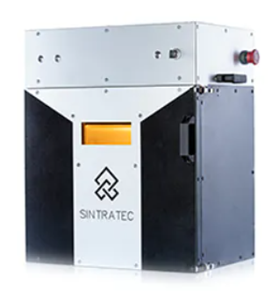
Figure 2. Sintratec Kit SLS Apparatus.
    - Method

The study embarked on an innovative journey to explore the recovery and reuse of unsintered powder in the Selective Laser Sintering (SLS) process, leveraging the unique capabilities of the Sintratec Kit SLS apparatus and the high-performance Sintratec PA12 Powder, alongside a fluidized bed column for effective aggregate separation (Macrì D. et al, 2020). This methodical approach aimed to enhance the sustainability and efficiency of SLS manufacturing processes. Here's how the study was meticulously structured to achieve its objectives:
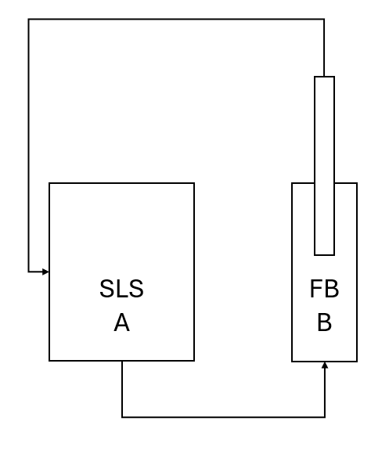
Figure 3. Process scheme.

The study began with the preparation of the Sintratec PA12 Powder, which was carefully loaded into the Sintratec Kit SLS apparatus. Ensuring proper setup and even distribution of the powder was crucial for optimal sintering conditions. The SLS printing process then followed, using specific parameters to fully utilize the potential of the PA12 powder.
After the sintering process, attention was focused on recovering the unsintered powder. This phase was essential for collecting the powder that had not been fused by the laser. The recovery process was conducted using an automatic suction system to ensure the transfer of all residual powder from the sintering process, including the aggregates formed during the process.
The recovered powder was then introduced into the fluidized bed column. Using an airflow, the powder was fluidized within the column to effectively separate larger aggregates from finer powder particles (Girimonte et al.,2018). This process aimed to restore the quality of the powder to make it suitable for reuse in the SLS process. The fluidized bed column played a crucial role in attempting to achieve this quality restoration.
The separated powder was then reloaded into the Sintratec Kit SLS apparatus for subsequent printing cycles. Throughout the study, each phase was designed to build upon the previous one, creating a comprehensive approach to exploring the recovery and reuse of powder in SLS printing. By combining the innovative use of the Sintratec Kit, the properties of PA12 powder, and the efficiency of the fluidized bed column, the study aimed to explore new possibilities in additive manufacturing.

  - Results and discussion

The study results showed that the upper layers of the fluidized bed column contained less mass, with a higher concentration of finer particles at the top. Consequently, it is necessary to recover the powder from the top of the bed to avoid the formation of aggregates, which tend to accumulate at the bottom of the column.
This observation suggests that the powder recovered from the upper layers, being finer and more homogeneous, can be further processed in the SLS apparatus using automated suction systems. This technique improves the efficiency and quality of the sintering process while ensuring the sustainability of powder reuse. As evident in Fig. 4, the automated recovery of powder from the upper layers of the fluidized bed can be integrated into the workflow to optimize production.

Figure 4. Particle size class profiles versus column height.

  - Conclusions
The findings of this study highlight the importance of an effective powder recovery strategy in the Selective Laser Sintering (SLS) process to enhance material efficiency and sustainability. Through the integration of a fluidized bed separation system, it has been demonstrated that unsintered powder can be successfully recovered and reused without compromising its properties. The recovered powder maintains a consistent particle size distribution and flowability, making it suitable for multiple reuse cycles in the SLS process.

The study provides compelling evidence that this method significantly reduces material waste, addressing one of the major challenges in additive manufacturing. By ensuring that high-quality powder is available for subsequent printing cycles, this approach not only minimizes production costs but also contributes to environmental sustainability by limiting the need for new raw materials. The ability to recycle and reuse powder without a loss in quality or efficiency marks a substantial advancement in sustainable manufacturing practices.
Additionally, the automated nature of the fluidized bed system presents a practical solution for industrial applications, reducing manual intervention and streamlining the powder recovery process. The reduction in downtime and material wastage further enhances the economic feasibility of this method, making it a viable solution for large-scale manufacturing environments.
Future research should focus on optimizing process parameters to further improve the efficiency of the powder recovery system. Investigations into the behavior of different powder materials under fluidized bed conditions and the impact of extended reuse cycles on mechanical properties will provide valuable insights for broader applications. Furthermore, integrating real-time monitoring technologies could enhance process control, ensuring consistent powder quality and system performance over time.
Overall, this study presents a robust and effective method for improving the sustainability and efficiency of the SLS process. By addressing key challenges related to powder reuse, this work contributes to the ongoing advancement of additive manufacturing technologies, paving the way for more resource-efficient and cost-effective production methods.
This study demonstrates that integrating a fluidized bed separation system within the SLS process enhances powder reuse, reduces material waste, and improves cost efficiency. The findings indicate that powder recovered from the upper layers of the fluidized bed column is of high quality and suitable for reuse, ensuring sustainable additive manufacturing practices. Future research will focus on optimizing process parameters to further enhance powder recovery efficiency.

References
Bertrand, P., Bayle, F., Combe, C., Goeuriot, P. and Smurov, I. (2007) ‘Ceramic components manufacturing by selective laser sintering’, Applied Surface Science, 254, pp. 989–992. doi:10.1016/j.apsusc.2007.08.085.
Girimonte, R., Formisani, B. and Vivacqua, V. (2018) ‘The relationship between fluidization velocity and segregation in two-component gas fluidized beds: Density- or size-segregating mixtures’, Chemical Engineering Journal, 338, pp. 63–73.
Gu, D.D., Meiners, W., Wissenbach, K. and Poprawe, R. (2012) ‘Laser additive manufacturing of metallic components: materials, processes and mechanisms’, International Materials Reviews, 57, pp. 133–164. doi:10.1179/1743280411Y.0000000014.
Kahrizsangi, S.H., Sofia, D., Barletta, D. and Poletto, M. (2015) ‘Dust generation in vibrated cohesive powders’, Chemical Engineering Transactions. doi:10.3303/CET1543129.
Liu, C., Xia, Z. and Czernuszka, J.T. (2007) ‘Design and development of three-dimensional scaffolds for tissue engineering’, Chemical Engineering Research and Design, 85, pp. 1051–1064. doi:10.1205/cherd06196.
Luo, X., Liu, Y., Gu, C. and Li, Z. (2014) ‘Study on the progress of solidification, deformation and densification during semi-solid powder rolling’, Powder Technology, 261, pp. 161–169. doi:10.1016/j.powtec.2014.04.001.
Lupo, M. et al. (2019) ‘Calibration of DEM simulation of cohesive particles’, Chemical Engineering Transactions. doi:10.3303/CET1974064.
Lupo, M. et al. (2023) ‘Experimental metrics of the powder layer quality in the selective laser sintering process’, Powder Technology. doi:10.1016/j.powtec.2023.11834.
Macrì, D. et al. (2020) ‘Characterization of the bulk flow properties of industrial powders from shear tests’, Processes, 8(5), p. 540. doi:10.3390/PR8050540.
Ojala, L.S., Uusi-Kyyny, P. and Alopaeus, V. (2016) ‘Prototyping a calorimeter mixing cell with direct metal laser sintering’, Chemical Engineering Research and Design, 108, pp. 146–151. doi:10.1016/j.cherd.2015.11.015.

